

College of Engineering

Information Technology Department

ITE 402 – Computer Networks: Design and Implementations

Lab One

**Introduction:**

This lab contains two parts and the main objectives of this lab are to achieve the following:

1. **First Part**: includes the importance of VLANs
   1. Learn how to configure Virtual Local Area Networks ( VLANs)
   2. How to sign VLANs to switch ports
2. **Second Part:** includes observing spanning-tree port states and watching the spanning-tree convergence process.
   1. Describe the operation of the Spanning Tree Protocol.
   2. Explain how Spanning Tree Protocol prevents switching loops while allowing redundancy in switched networks.

**PART ONE**

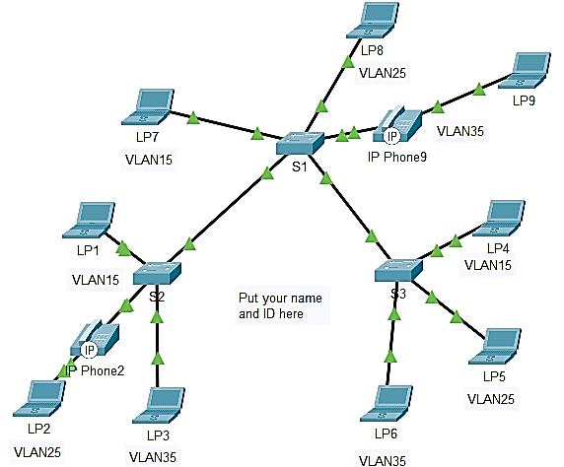

**Addressing Table**

|  |  |  |  |  |
| --- | --- | --- | --- | --- |
| Device | Interface | IP Address | Subnet Mask | VLAN |
| LP1 | f0/1 | 172.17.10.<10> | 255.255.224.0 | 15 |
| LP2 | f0/3 | 172.17.20. <17> | 255.255.224.0 | 25 |
| LP3 | 0/2 | 172.17.30. <18> | 255.255.224.0 | 35 |
| LP4 | 0/2 | 172.17.10. <19> | 255.255.224.0 | 15 |
| LP5 | 0/1 | 172.17.20. <20> | 255.255.224.0 | 25 |
| LP6 | 0/3 | 172.17.30. <24> | 255.255.224.0 | 35 |
| LP7 | 0/1 | 172.17.10. <13> | 255.255.224.0 | 15 |
| LP8 | 0/2 | 172.17.20. <69> | 255.255.224.0 | 25 |
| LP9 | 0/3 | 172.17.30. <105> | 255.255.224.0 | 35 |

This Addressing table contains data about the IP addresses, subnet masks, and VLANs appointed to various connection points on different devices. The devices recorded incorporate LP1 through LP9, and their particular connection points are recorded as f0/1, f0/3, 0/2, 0/1, etc. The IP addresses allocated to every connection point are special and are as 172.17.x.y, where x is the network ID and y is the host ID. The subnet veil utilized is 255.255.224.0, which gives a scope of IP addresses for each organization. The VLANs recorded range from 15 to 35 and figure out which network every connection point has a place with.

**Note**

The formula <XY> in the above addressing table refers to your university ID. Assume that the id 1023456 is used, then <12> means 10 and <15+3> means ( 14+3 = 17 ), and so on.

**Introduction**

VLANs are helpful in the administration of logical groups, allowing members of a group to be easily moved, changed, or added. This activity focuses on creating and naming VLANs, and assigning access ports to specific VLANs.

**Tasks**

1. On S1, issue the command that displays all VLANs configured. By default, all interfaces are assigned to VLAN 1. By issuing the command

**S1# show vlan brief**

|  |
| --- |
| VLAN Name Status Ports  ---- -------------------------------- --------- -------------------------------  1 default active Fa0/1, Fa0/2, Fa0/3, Fa0/4  Fa0/5, Fa0/6, Fa0/7, Fa0/8  Fa0/9, Fa0/10, Fa0/11, Fa0/12  Fa0/13, Fa0/14, Fa0/15, Fa0/16  Fa0/17, Fa0/18, Fa0/19, Fa0/20  Fa0/21, Fa0/22, Fa0/23, Fa0/24  Gig0/1, Gig0/2  1002 fddi-default active  1003 token-ring-default active  1004 fddinet-default active  1005 trnet-default active  S1# |

1. Carry out the following pings between different end node that shares the same subnet.

* LP7 can ping LP1
* LP8 can ping LP2
* LP9 can ping LP3

|  |
| --- |
| **Output of LP7 ping LP1**    **Output of LP8 ping LP2**    **Output LP9 ping LP3** |

**Question**: What benefits can VLANs provide to the network?

|  |
| --- |
| The advantages of VLANs incorporate the simpler organization and the board of sensible gatherings, further developed security by detaching traffic, and more effective utilization of organization resources. |

Type your answers here.

1. VLANs creations and naming on S1.
   * + 1. Create the following VLANs. Names are case-sensitive and must match the requirement exactly:

* VLAN 15: staff-<Your last name>

Open configuration window

S1#(config)# **vlan 15**

S1#(config-vlan)# **name Staff-*<your—last-name>***

|  |
| --- |
| **Output** |

* + - 1. Create the remaining VLANS.
* VLAN 25: Students***-<your-first-name>***
* VLAN 35: Guest(Default)
* VLAN 75: Management
* VLAN 45: VOICE

|  |
| --- |
| **Creating Vlan:** |

* + - 1. In order to verify your VLAN configurations, you can display the VLAN name, status, and associated ports on a switch, you can invoke the following command in the CLI screen:

**S1# show vlan brief**

|  |
| --- |
| S1#show vlan brief  VLAN Name Status Ports  ---- -------------------------------- --------- -------------------------------  1 default active Fa0/4, Fa0/5, Fa0/6, Fa0/7  Fa0/8, Fa0/9, Fa0/10, Fa0/11  Fa0/12, Fa0/13, Fa0/14, Fa0/15  Fa0/16, Fa0/17, Fa0/18, Fa0/19  Fa0/20, Fa0/21, Fa0/22, Fa0/23  Fa0/24, Gig0/1, Gig0/2  15 Staff-Alzaabi active Fa0/1  25 Student-Rashid active Fa0/2  35 Guest(Default) active Fa0/3  45 VOICE active  75 Management active  1002 fddi-default active  1003 token-ring-default active  1004 fddinet-default active  1005 trnet-default active |

1. Create and configure the same VLANs on both S2 and S3

|  |
| --- |
| S2 Configuration        **Sow Vlan Brief**  VLAN Name Status Ports  ---- -------------------------------- --------- -------------------------------  1 default active Fa0/4, Fa0/5, Fa0/6, Fa0/7  Fa0/8, Fa0/9, Fa0/10, Fa0/11  Fa0/12, Fa0/13, Fa0/14, Fa0/15  Fa0/16, Fa0/17, Fa0/18, Fa0/19  Fa0/20, Fa0/21, Fa0/22, Fa0/23  Fa0/24, Gig0/1, Gig0/2  15 Staff-Alzaabi active Fa0/1  25 Students-Rashid active Fa0/3  35 Guest(Default) active Fa0/2  45 VOICE active  75 Management active  1002 fddi-default active  1003 token-ring-default active  1004 fddinet-default active  1005 trnet-default active  S2#  **S3 Vlan Configuration**    **Show Vlan Brief**  VLAN Name Status Ports  ---- -------------------------------- --------- -------------------------------  1 default active Fa0/4, Fa0/5, Fa0/6, Fa0/7  Fa0/8, Fa0/9, Fa0/10, Fa0/11  Fa0/12, Fa0/13, Fa0/14, Fa0/15  Fa0/16, Fa0/17, Fa0/18, Fa0/19  Fa0/20, Fa0/21, Fa0/22, Fa0/23  Fa0/24, Gig0/1, Gig0/2  15 Staff-Alzaabi active Fa0/2  25 Students-Rashid active Fa0/1  35 Guest(Default) active Fa0/3  45 VOICE active  75 Management active  1002 fddi-default active  1003 token-ring-default active  1004 fddinet-default active  1005 trnet-default active  S3# |

.

1. Which command will only display the VLAN name, status, and associated ports on S2 and S3? And what is the output?

|  |
| --- |
| Show Vlan brief  This command will show a short synopsis of all the VLANs designed on the switch, including their names, status (dynamic or suspended), and the rundown of ports related to each VLAN.  The output of S2 is    The output of S3 is |

lose configuration window

1. Steps of assigning VLANs to the active ports on S1.
   * + 1. Configure the interfaces as access ports and assign the VLANs as follows:

* VLAN 15: FastEthernet 0/<port number>

Open configuration window

S1(config)# **interface f0/<port number> -🡪 interface f0/12 for instance**

S1(config-if)# **switchport mode access**

S1(config-if)# **switchport access vlan 15**

* + - 1. Assign the remaining ports to the appropriate VLAN depending on the switch ports you used in your network design.
* VLAN 25: FastEthernet 0/<port number>
* VLAN 35: FastEthernet 0/<port number>

|  |
| --- |
| **Assigning ports to Vlans** |

1. Configure the interfaces as access ports and assign the VLANs for both S2 and S3 as per the topology above and the addressing table

|  |
| --- |
| **Configuration for S2 and S3 Vlans** |

1. How to assign the VOICE VLAN.

As shown in the topology, the S1 and S2 FastEthernet 0/<port number> interface connect to a Cisco IP Phone and LP2 and LP2 respectively. The IP phone contains an integrated three-port 10/100 switch. One port on the phone is labeled Switch and connects to F0/<port>. Another port on the phone is labeled PC and connects to the appropriate LP. The IP phone also has an internal port that connects to the IP phone functions.

The S2 F0/<port> interface must be configured to support user traffic to LP2 using VLAN 25 and voice traffic to the IP phone using VLAN 45. The interface must also enable QoS and trust the Class of Service (CoS) values assigned by the IP phone. IP voice traffic requires a minimum amount of throughput to support acceptable voice communication quality. This command helps the switchport to provide this minimum amount of throughput.

S1(config)# **interface f0/<port number> 🡪 assign the appropriate port number**

S1(config-if)# **mls qos trust cos**

S1(config-if)# **switchport voice vlan 45**

1. Now you are required to assign the VOICE VLAN on S2

|  |
| --- |
| **Assign Voice Vlan on S2** |

1. Previously, PCs that shared the same network could ping each other successfully.
   1. Study the output of from the following command on **S1** and answer the following questions based on your knowledge of the communication between VLANS. Pay close attention to the Gig0/1 port assignment.

S1# **show vlan brief**

|  |
| --- |
| **Based on S1 Output**  VLAN Name Status Ports  ---- -------------------------------- --------- -------------------------------  1 default active Fa0/4, Fa0/5, Fa0/6, Fa0/7  Fa0/8, Fa0/9, Fa0/10, Fa0/11  Fa0/12, Fa0/13, Fa0/14, Fa0/15  Fa0/16, Fa0/17, Fa0/18, Fa0/19  Fa0/20, Fa0/21, Fa0/22, Fa0/23  Fa0/24, Gig0/1, Gig0/2  15 Staff-Alzaabi active Fa0/1  25 Student-Rashid active Fa0/2  35 Guest(Default) active Fa0/3  45 VOICE active Fa0/3  75 Management active  1002 fddi-default active  1003 token-ring-default active  1004 fddinet-default active  1005 trnet-default active  **Answers**  There are 6 VLANs designed on the switch.  Ports Fa0/4 to Fa0/23 and Gig0/1 and Gig0/2 are individuals from VLAN 1.  Port Fa0/3 is an individual from VLAN 45.  VLAN 45 is utilized for voice traffic.  Ports Gig0/1 and Gig0/2 are assigned to the default VLAN |

* 1. Issue a ping command from LP8 and LP6. Show the output and explain your observation.

|  |
| --- |
|  |

* 1. If there are any problems in the ping command above? What could be done to resolve the issue?

|  |
| --- |
| Because LP8 is Vlan 25 and LP6 is a part of Vlan 35 different vlans cannot ping with each other same Vlans are ping with each other successfully.  The only solution for this issue is to make bath LPs same Vlan part. |

* 1. Now issue the ping command from LP2 and LP5 and observe the output

|  |
| --- |
| We need to trunk switch port.    **Troubleshooting** |

**Reflection Question**: What are the purposes of creating VLANs and when do they need to be created?

|  |
| --- |
| **Answer**  VLANs are made to work on a network of executives and administrators, further develop security, and upgrade network execution. They ought to be made at whatever point there is a need to logically group network gadgets, for example, when a gathering of gadgets requires explicit security strategies or organization assets. |

**PART Two**

**Instructions**

In this lab, you will use Packet Tracer to design the network below and observe the operation of Spanning Tree Protocol in a simple switched network that has redundant paths.

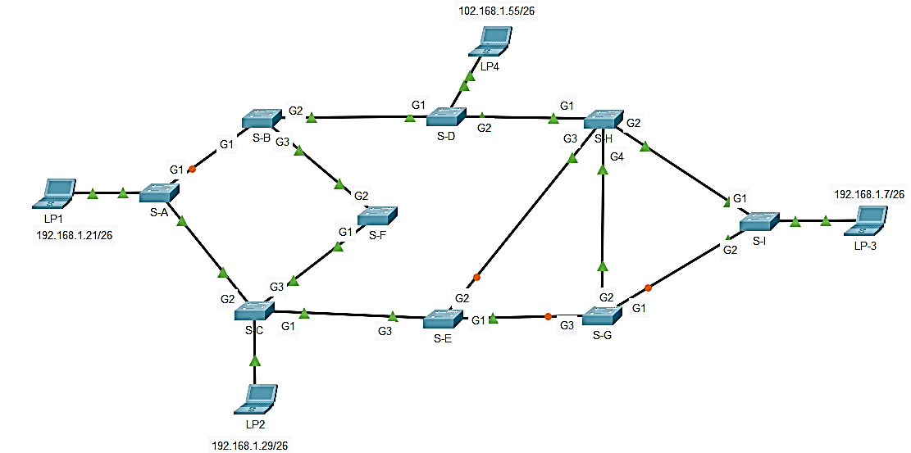

1. Ping from LP1 to LP3 to verify connectivity between the hosts. Your ping should be successful.

|  |
| --- |
| **Ping Output working properly from LP1 to LP3** |

1. Use the **show spanning-tree vlan 1** command to gather information about the spanning tree status of each switch. Complete the table. For the purposes of the activity, only consider information about the Gigabit trunk ports. The Fast Ethernet ports are access ports that have end devices connected and are not part of the inter-switch trunk-based spanning tree.

|  |  |  |  |
| --- | --- | --- | --- |
| Switch | Port | Status (FWD,BLK…) | Root Bridge? |
| S-A | Gi8/1 | Altn BLK 4 | 128.1 P2p |
| Gi7/1 | Root FWD 4 | 128.2 P2p |
| S-B | Gi9/1 | Desg FWD 4 | 128.1 P2p |
| Gi7/1 | Desg FWD 4 | 128.3 P2p |
| Gi8/1 | Root FWD 4 | 128.2 P2p |
| S-C | Gi8/1 | Desg FWD 4 | 128.2 P2p |
| Gi9/1 | Root FWD 4 | 128.1 P2p |
| Gi7/1 | Desg FWD 4 | 128.3 P2p |
| S-D | Gi9/ | 1 Desg FWD 19 | 128.1 P2p |
| Gi8/1 | Desg FWD 4 | 128.2 P2p |
| Gi7/1 | Root FWD 4 | 128.3 P2p |
| S-E | Gi7/1 | Altn BLK 4 | 128.3 P2p |
| Gi8/1 | Desg FWD 4 | 128.2 P2p |
| Gi9/1 | Root FWD 4 | 128.1 P2p |
| S-F | Gi8/1 | Root FWD 4 | 128.2 P2p |
| Gi9/1 | Desg LSN 4 | 128.1 P2p |
| S-G | Gi8/1 | Root FWD 4 | 128.2 P2p |
| Gi9/1 | Desg FWD 4 | 128.1 P2p |
| Gi7/1 | Desg FWD 4 | 128.3 P2p |
| S-H | Gi9/1 | Root FWD 4 | 128.1 P2p |
| Gi6/1 | Desg FWD 4 | 128.4 P2p |
| Gi8/1 | Altn BLK 4 | 128.2 P2p |
| Gi7/1 | Desg FWD 4 | 128.3 P2p |
| S-I | Gi9/1 | Desg FWD 4 | 128.1 P2p |
| Gi8/1 | Desg FWD 4 | 128.2 P2p |

Open configuration window

1. Packet Tracer uses a different link light on one of the connections between the switches. What do you think this link light means?

|  |
| --- |
| **Ans**  The importance of the connection light can differ contingent upon the particular equipment or programming utilized. For the most part, a green or strong connection light demonstrates that the connection is dynamic and there is a decent association, while a flickering or blazing connection light might show action or information move. A red or golden connection light might show an issue, like a fizzled or disengaged interface.  On account of an alternate connection light on one of the associations between switches, it is conceivable that there is a setup contrast on that connection, for example, an alternate VLAN or QoS setting. |

1. What path will frames take from LP1 to LP3?

|  |
| --- |
| The output of path which packet will take from LP1 to LP3 |

1. Why do the frames not travel through S-G when communicating in the previous question?

|  |
| --- |
| **Ans**  In the past inquiry, assuming we expect that the source device LP1 and objective devise LP3 are on various organizations that are associated by switches S-An and S-B, then the casings wouldn't go through switch S-G while conveying since it isn't on the way somewhere in the range of LP1 and LP3. All things considered, the edges would go through switches S-An and S-B, which are the switches that interface the two networks.  It's critical to take note of the particular way that casings take on an organization that can rely upon many variables, including the organization's geography, directing conventions, and VLAN setups. Subsequently, it's dependably really smart to talk with an organization executive or specialist who knows all about the network to guarantee exact following of the way of edges. |

1. Why has the spanning tree placed ports in a blocking state?

|  |
| --- |
| **Ans**  The Spanning Tree Protocol (STP) is utilized to forestall loops in a network topology. At the point when there are excess ways between switches, STP chooses one way as the dynamic way and spots the other repetitive ways in a hindering state. This keeps circles from framing in the organization, which can cause broadcast storms and different issues.  STP chooses the dynamic way founded on a few elements, including the scaffolding need, bridge ID, and port need. The switch with the most minimal scaffold ID turns into the root extension, and STP chooses the briefest way to the root bridge as the dynamic way. Any repetitive ways that are not a piece of the dynamic way are set in an impeding state.  The impending condition of ports guarantees that no casings are sent through these ports, which keeps loops from shaping. While a hindering port gets an edge, it disposes of the casing and sends a BPDU (Bridge Protocol Data Unit) to illuminate different switches on the organization that the port is obstructed. |

Close configuration window

1. Now you are required to delete some links to see the spanning tree convergence:
   1. Open a CLI window on switch S-H and issue the command **show spanning-tree vlan 1**. Leave the CLI window open.

|  |
| --- |
| **Delete links** |

Open configuration window

* 1. Select the delete tool from the menu bar and click the cable that connects S-H and S-D.

|  |
| --- |
| Show snapshot after spanning-tree converged |

* 1. Repeat (a) above for switch S-G

|  |
| --- |
|  |

* 1. Now select delete the cable that connects S-G and S-H

|  |
| --- |
| Show snapshot after spanning-tree converged |

#### Questions:

1. What do you see happen to the status of the G0/2 port of S-H during this process?

|  |
| --- |
| **Ans**  In general, the situation with the G0/2 port of S-H will change as STP recalculates the dynamic way and spots excess ways in an impeding state to forestall circles. The port might change from a sending state to an impeding state, or the other way around, contingent upon the network topology and STP setup.  During the course of STP assembly, it's normal for ports to change between sending, obstructing, and listening states on different occasions before the network topology balances out. This is a typical way of behaving and doesn't be guaranteed to show an issue with the organization. It's vital to be patient and permit STP to finish its union interaction prior to rolling out any further improvements to the network topology. |

You have observed the transition in port status that occurs as a spanning-tree port moves from blocking to the forwarding state.

1. Verify Connectivity by pinging from LP1 to LP4. Your ping should be successful.

|  |
| --- |
| **Pinging from LP1 to LP4**    **Troubleshooting** |

* + - 1. Show the path of the traveling packet when pinging LP1 to LP4

|  |
| --- |
| **Path of the traveling packet when pinging LP1 to LP4** |

* + - 1. Are any ports showing an orange link light that indicates that the port is in a spanning-tree state other than forwarding? Why or why not?

|  |
| --- |
| **Ans**    Yes, in this topology there are 4 interfaces which have blink orange light.  At the point when STP is enabled on a switch, the switch at first places all ports in a blocking state to keep loops from happening in the network. The switch then decides the best way to the root extension and spots the ports in the sending state on that way.  In the event that the switch identifies an adjustment of the network topology, it will start a re-combination process where it rethinks the network topology and may impact the condition of at least one port. During this cycle, ports may briefly be set in a hindering state until the new is not entirely set in stone.  Setup issues can likewise make ports be set in a crossing tree state other than sending. For instance, on the off chance that a port is physically designed to be in a crippled state, it won't advance traffic regardless of whether the port is genuinely associated and dynamic |

**Now delete all blocked links in the network and show the final status of the spanning tree**.

|  |
| --- |
| Show snapshot after spanning-tree converged |

Notes:

1. The Lab is worth 5%
2. The Lab is an individual Lab
3. Submission deadline is no later than 16th April 2023
4. Submissions are accepted only via Blackboard.
5. You are required to submit your packet tracer file along with screenshots of your Lab in a Word document file.
6. Any delay in the submission will have a 0.25 reduction penalty per day.
7. It is recommended to provide a short video showing part of work. This could be done using bandicam screen recorder by clicking [here](https://www.bandicam.com/free-screen-recorder/)